SIMATS ENGINEERING
ASSESSMENT TOOL 1

COURSE NAME: Database Management Systems
COURSE CODE: CSA05

COURSE OUTCOME COVERED

CO1: Analyze DBMS architecture, different data models, schema types, and design ER/EER diagrams, relational schemas for case-based scenarios by identifying entities and relationships. (BL1, BL2)

Activity Tool : Short Answer Text(High)
Assessment Tool Weightage: 40%

QUESTIONS
Q. No | Question | Bloom's Level
1 | Explain schema and instance with examples. Distinguish between logical schema, physical schema, and view schema. | BL1 – Remember
2 | Identify the entities, attributes, and relationships for a Bank Management System and construct its ER diagram. | BL2 – Understand
3 | Explain the Extended ER (EER) model. Describe the concepts of generalization, specialization, and aggregation. | BL2 – Understand
4 | Design an EER diagram for a Hospital Management System incorporating inheritance and weak entities. | BL2 – Understand
5 | Explain the role of a DBA (Database Administrator) and the responsibilities associated with the position. | BL1 – Remember

Code of Conduct:

I ___Deepthi Korrapati (192572012)___ (Name / Reg No) certify that this submission is my original work and that I have adhered to the guidelines specified for this assessment.
I understand that any violation of academic integrity rules will result in disciplinary action.

Signature of the student:

RUBRICS FOR CALCULATION:

Criteria | Weightage | Level 4 (Exemplary) | Level 3 (Proficient) | Level 2 (Developing) | Level 1 (Beginning)
Concept Identification | 30% | Demonstrates  clear and  complete  understanding of  the concept | Good  understanding  with minor  gaps | Basic  understanding  with some  misconceptions | Poor or  incorrect  understandin  g
Linkages | 25% | Completely  correct answer  with no errors | Mostly correct  with minor  errors | Partially correct  with noticeable  errors | Incorrect or  irrelevant  answer
Organization | 20% | Correctly applies  concepts to solve  the  question/problem | Applies  concepts with  minor  mistakes | Limited or  partially correct  application | No or  incorrect  application
Integration of Literature | 15% | Covers all  required parts of  the question | Covers most  parts with  minor  omissions | Covers only  some parts | Incomplete  or missing  response
Clarity | 10% | Clear, concise,  and well-  organized answer | Understandabl  e with minor  issues | Somewhat  unclear or poorly  structured | Difficult to  understand

QUESTION 1

Explain schema and instance with examples. Distinguish between logical schema, physical schema, and view schema.

EXPLANATION/ANSWER:

Schema and Instance
In a Database Management System (DBMS), schema and instance are two important concepts.

Introduction

A Database Management System (DBMS) is software used to create, store, retrieve, and manage data efficiently. To understand how a database works, two fundamental concepts are schema and instance. A schema defines the structure of the database, whereas an instance represents the actual data stored in the database at a specific point in time. DBMS also uses different levels of schemas—logical schema, physical schema, and view schema—to provide data abstraction and independence.

1. Schema
A schema is the logical structure or blueprint of a database. It defines how the data is organized, including tables, attributes (columns), data types, relationships, and constraints. The schema changes very rarely.
Example:
Consider a Student table:
Student_ID | name | department | age
Schema of the table:
Student(Student_ID INT, Name VARCHAR(50), Department VARCHAR(30), Age INT)
Here, the schema specifies the table name, column names, and data types.

Advantages of Schema
- Provides a clear database structure.
- Maintains consistency in data organization.
- Simplifies database maintenance.

2. Instance
An instance is the actual data stored in the database at a particular moment. It changes frequently as records are inserted, updated, or deleted.
Example:

Student_ID | Name | Department | Age
101 | Rahul | CSE | 20
102 | Amit | IT | 19
103 | Priya | ECE | 21

Characteristics of Instance
- Represents the current state of the database.
- Changes frequently.
- Also called Extension.
- Depends on user operations.
- Can have multiple instances while the schema remains the same.
This table represents one instance of the Student database.
If another student is added:
Student_ID | Name | Department | Age
104 | Sneha | CSE | 20
the instance changes, but the schema remains unchanged

Difference between Schema and Instance
Schema and instance are two fundamental concepts in a Database Management System (DBMS). A schema is the blueprint or logical structure of a database that defines the tables, attributes, data types, relationships, and constraints. It is created during the database design phase and changes very rarely. In contrast, an instance is the actual data stored in the database at a particular point in time. Unlike the schema, the instance changes frequently whenever data is inserted, updated, or deleted. Schema is also known as intension, whereas instance is called extension. In simple terms, the schema describes how the database is organized, while the instance represents the current contents of the database. For example, the definition of a Student table with columns such as Student_ID, Name, Department, and Age is the schema, whereas the records of students stored in that table at a given time constitute the instance.

Database Schema Architecture
A DBMS follows the Three-Schema Architecture, which separates the database into three levels:
- View (External) Schema
- Logical (Conceptual) Schema
- Physical (Internal) Schema
This architecture provides data abstraction and data independence.

1. Logical Schema (Conceptual Schema)

Definition
The logical schema describes the logical structure of the entire database. It specifies tables, attributes, relationships, keys, constraints, and integrity rules without considering physical storage.

Features
- Describes what data is stored.
- Independent of physical storage.
- Represents the complete database.
- Defines relationships among tables.
- Used by database designers.

Employee(
Emp_ID INT PRIMARY KEY,
Emp_Name VARCHAR(50),
Salary DECIMAL(10,2),
Department VARCHAR(30)
)
This schema only defines the logical structure.

Advantages
- Easy to understand.
- Supports database normalization.
- Provides logical data independence.
- Simplifies database design.

2. Physical Schema (Internal Schema)

Definition
The physical schema describes how data is physically stored in the storage device. It includes file organization, indexing methods, storage allocation, record formats, hashing techniques, and disk structures.

Features
- Describes physical storage.
- Managed by DBMS.
- Includes indexes and storage methods.
- Optimizes database performance.
- Hidden from users.

Example
The Employee table may be stored as follows:
- Records stored in disk blocks.
- B+ Tree index on Emp_ID.
- Heap file organization.
- Data compressed for efficient storage.
Users do not see these storage details.

Advantages
- Faster data retrieval.
- Efficient storage management.
- Better indexing.
- Improved query performance.

3. View Schema (External Schema)

Definition
The view schema represents different user views of the database. Different users access only the information relevant to them.

Features
- User-specific view.
- Hides unnecessary information.
- Provides security.
- Multiple views can exist for one database.
- Simplifies user interaction.

Example
Employee table:
Emp_ID | Name | Salary | Department

HR View
Emp_ID | Name | Salary | Department
HR can see all information.

Employee View
Emp_ID | Name | Department

Advantages
- Improves security.
- Protects confidential information.
- Simplifies complex databases.
- Allows customized user access.

Difference Between Logical Schema, Physical Schema, and View Schema (Paragraph-wise)
Logical Schema:
The logical schema, also known as the conceptual schema, describes the overall logical structure of the database. It defines what data is stored, including tables, attributes, relationships, primary keys, foreign keys, and integrity constraints, without considering how the data is physically stored. It provides a complete view of the database for designers and developers and remains independent of the storage devices. For example, an Employee table with attributes such as Emp_ID, Name, Salary, and Department is part of the logical schema.
Physical Schema:
The physical schema, also known as the internal schema, describes how the data is actually stored in the database. It includes storage structures such as files, indexes, disk blocks, record formats, hashing techniques, and access methods. The physical schema is managed by the DBMS and database administrators to improve storage efficiency and query performance. End users are not aware of these storage details. For example, storing employee records in disk blocks with a B+ tree index on Emp_ID is part of the physical schema.
View Schema:
The view schema, also called the external schema, defines how different users or user groups view the database. It presents only the data required by a particular user while hiding unnecessary or sensitive information, thereby improving security and simplifying database access. Multiple view schemas can exist for the same database depending on user requirements. For example, the HR department may view employee names, salaries, and departments, whereas regular employees may only view employee names and departments, with salary details hidden.

Three-Schema Architecture
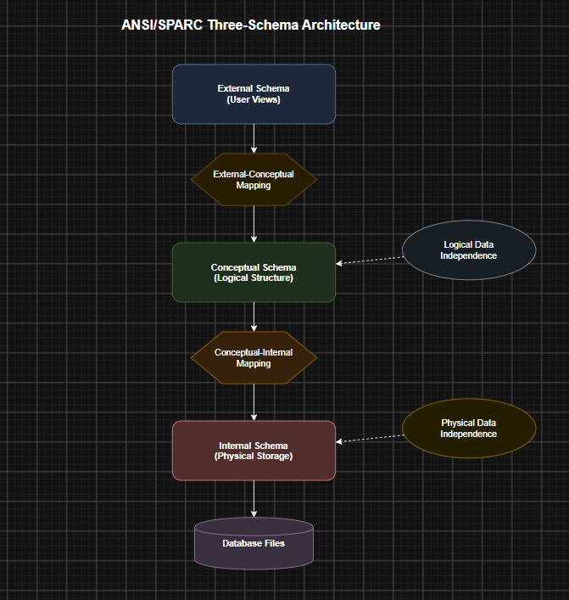

Benefits of Three-Schema Architecture
- Provides data abstraction.
- Ensures logical data independence.
- Ensures physical data independence.
- Improves database security.
- Allows multiple user views.
- Simplifies database maintenance.
- Enhances scalability and flexibility.

Applications
- Banking systems
- Hospital management systems
- University databases
- Library management systems
- E-commerce websites
- Airline reservation systems
- Inventory management systems

Conclusion
Schema and instance are the foundation of database systems. A schema defines the structure of the database, while an instance represents the actual data stored at a particular time. The logical schema defines the logical organization of data, the physical schema describes how data is stored internally, and the view schema presents customized views for different users. Together, these three schemas form the three-schema architecture, providing data abstraction, security, flexibility, and efficient database management.

***

QUESTION 2

Identify the entities, attributes, and relationships for a Bank Management System and construct its ER diagram.

EXPLANATION/ANSWER:

Introduction
A Bank Management System is used to manage customer information, bank accounts, transactions, loans, and branch details. An Entity-Relationship (ER) diagram represents the database structure by identifying entities, their attributes, and the relationships among them.

1. Entities and Attributes

Entity 1: Customer
Attributes:
- Customer_ID (Primary Key)
- Customer_Name
- Address
- Phone_Number
- Email
- Date_of_Birth

Entity 2: Account
Attributes:
- Account_Number (Primary Key)
- Account_Type
- Balance
- Opening_Date
- Customer_ID (Foreign Key)

Entity 3: Branch
Attributes:
- Branch_ID (Primary Key)
- Branch_Name
- Branch_Address
- IFSC_Code

Entity 4: Transaction
Attributes:
- Transaction_ID (Primary Key)
- Transaction_Date
- Transaction_Type
- Amount
- Account_Number (Foreign Key)

Entity 5: Loan
Attributes:
- Loan_ID (Primary Key)
- Loan_Type
- Loan_Amount
- Interest_Rate
- Customer_ID (Foreign Key)

2. Relationships
- A Customer owns one or more Accounts (1:M).
- An Account records many Transactions (1:M).
- A Branch maintains many Accounts (1:M).
- A Customer applies for one or more Loans (1:M).
- A Branch sanctions many Loans (1:M).

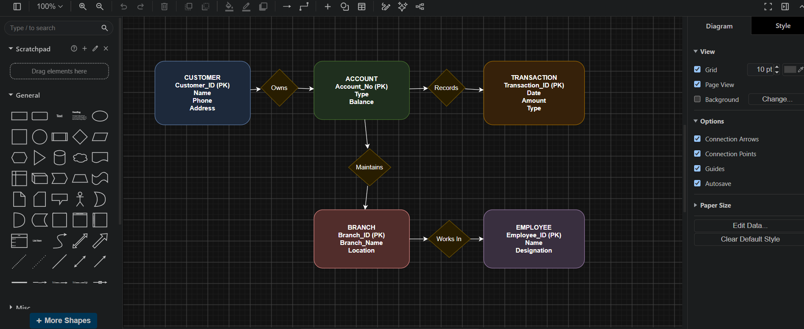

4. Summary
Entity | Primary Key
Customer | Customer_ID
Account | Account_Number
Branch | Branch_ID
Transaction | Transaction_ID
Loan | Loan_ID

Relationship Cardinalities
- Customer → Account = 1 : M
- Account → Transaction = 1 : M
- Branch → Account = 1 : M
- Customer → Loan = 1 : M
- Branch → Loan = 1 : M
.

QUESTION 3:

Explain the Extended ER (EER) model. Describe the concepts of generalization, specialization, and aggregation.

EXPLANATION/ANSWER:

Introduction
The Extended Entity-Relationship (EER) Model is an enhanced version of the Entity-Relationship (ER) model. It extends the basic ER model by introducing advanced concepts such as generalization, specialization, aggregation, inheritance, and categorization. These concepts help represent complex real-world situations more accurately and make database design more flexible and expressive.

Extended Entity-Relationship (EER) Model

Definition
The Extended Entity-Relationship (EER) Model is an advanced data model that extends the traditional ER model by adding additional semantic concepts such as generalization, specialization, aggregation, and inheritance. It is used to model complex databases where entities share common properties or participate in higher-level relationships.
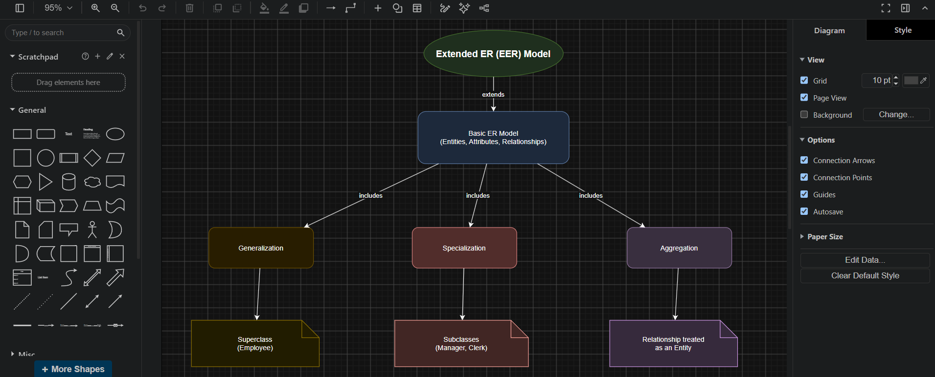

Features of EER Model
- Extends the basic ER model.
- Supports inheritance of attributes and relationships.
- Represents superclass and subclass relationships.
- Reduces redundancy in database design.
- Improves data abstraction and modeling capability.
- Suitable for large and complex database applications.

Advantages
- Represents real-world situations more accurately.
- Promotes data reusability through inheritance.
- Reduces duplication of attributes.
- Simplifies database design.
- Improves maintainability and scalability.

1. Generalization

Definition
Generalization is the process of combining two or more lower-level entity types that share common characteristics into a single higher-level entity called a superclass.
In generalization, common attributes are moved to the superclass, while unique attributes remain in the subclasses.

Example
Suppose a university database contains the entities:
- Student
- Faculty
Both have common attributes such as ID, Name, Address, and Phone Number.
These common attributes are generalized into a superclass called Person.
PERSON
-----------------
Person_ID
Name
Address
Phone
-----------------
/ \
/ \
STUDENT FACULTY
Roll_No Employee_ID
Course Designation

Advantages
- Eliminates redundancy.
- Improves data organization.
- Promotes inheritance.

2. Specialization

Definition
Specialization is the opposite of generalization. It is the process of dividing a higher-level entity (superclass) into lower-level specialized entities (subclasses) based on distinguishing characteristics.
Each subclass inherits all attributes of the superclass and may have additional attributes.

Example
Consider an Employee entity.
It can be specialized into:
- Manager
- Clerk
- Engineer
EMPLOYEE
------------------
Emp_ID
Name
Salary
------------------
/ | \
/ | \
Manager Clerk Engineer
Bonus Shift Skill

Advantages
- Represents different categories of an entity.
- Supports inheritance.
- Improves database clarity.

3. Aggregation

Definition
Aggregation is a process in which a relationship between entities is treated as a higher-level entity so that it can participate in another relationship.
It is useful when a relationship itself has another relationship with another entity.

Example
Suppose:
- Employee works on Project.
- Department monitors this work.
Instead of connecting the Department directly to Employee or Project, the relationship Works_On is treated as a single entity using aggregation.
EMPLOYEE -------- Works_On -------- PROJECT
|
|
MONITORED BY
|
DEPARTMENT

Advantages
- Represents complex relationships.
- Improves database modeling.
- Simplifies relationship representation.

Difference Between Generalization, Specialization, and Aggregation
Generalization | Specialization | Aggregation
Combines multiple lower-level entities into one higher-level entity | Divides one higher-level entity into multiple lower-level entities | Treats a relationship as an entity
Bottom-up approach | Top-down approach | Higher-level abstraction
Creates a superclass | Creates subclasses | Creates an abstract entity from a relationship
Reduces redundancy | Adds detailed classification | Models relationships among relationships
Example: Student and Faculty → Person | Employee → Manager, Clerk | Employee works on Project monitored by Department

Conclusion
The Extended Entity-Relationship (EER) Model enhances the traditional ER model by introducing concepts such as generalization, specialization, and aggregation. Generalization combines similar entities into a superclass, specialization divides a superclass into subclasses based on specific characteristics, and aggregation treats a relationship as a higher-level entity. These concepts improve database design by reducing redundancy, supporting inheritance, and representing complex real-world relationships effectively. This makes the EER model suitable for designing large and sophisticated database systems.

QUESTION 4:

Design an EER diagram for a Hospital Management System incorporating inheritance and weak entities.

EXPLANATION/ANSWER:

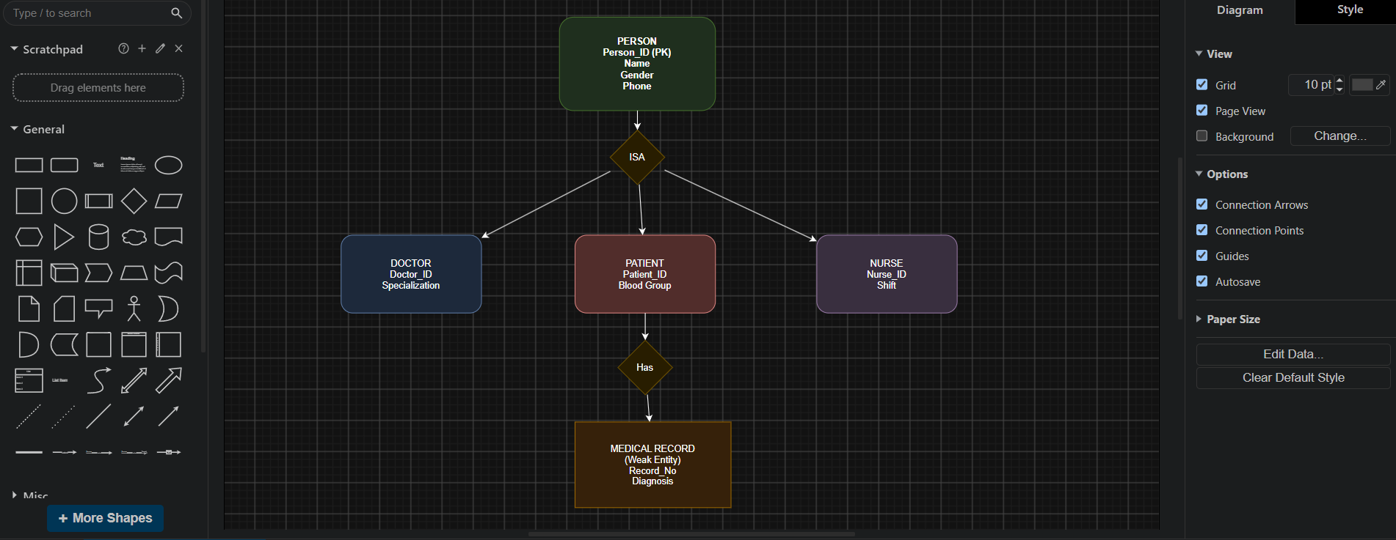

Introduction
A Hospital Management System (HMS) is designed to manage hospital operations such as patient registration, doctor information, appointments, treatments, prescriptions, and room allocation. The Extended Entity-Relationship (EER) model is used to represent advanced concepts like inheritance (generalization/specialization) and weak entities, making the database more efficient and organized.

Entities in the Hospital Management System

1. Person (Superclass)
The Person entity is the superclass because every individual in the hospital shares common information.
Attributes:
- Person_ID (Primary Key)
- Name
- Address
- Date_of_Birth
- Gender
- Phone

2. Patient (Subclass)
The Patient entity inherits all common attributes from Person and includes patient-specific details.
Additional Attributes:
- Patient_ID
- Blood_Group
- Allergies

3. Doctor (Subclass)
The Doctor entity inherits the attributes of Person and stores medical information.
Additional Attributes:
- Doctor_ID
- Specialization
- Qualification

4. Staff (Subclass)
The Staff entity also inherits from Person.
Additional Attributes:
- Staff_ID
- Department
- Designation

5. Department
Stores information about hospital departments.
Attributes:
- Dept_ID (Primary Key)
- Dept_Name
- Location

6. Room
Stores details of hospital rooms.
Attributes:
- Room_No (Primary Key)
- Room_Type
- Floor

Weak Entities
Weak entities cannot exist without their owner entity.

1. Visit (Weak Entity)
A Visit represents a patient's hospital visit. It depends on the Patient entity for identification.
Attributes:
- Visit_ID (Partial Key)
- Visit_Date
- Reason

2. Prescription (Weak Entity)
A Prescription is generated during a patient visit and depends on the Visit entity.
Attributes:
- Prescription_ID (Partial Key)
- Medicine
- Dosage
- Instructions

3. Test (Weak Entity)
A Test is conducted during a visit and depends on the Visit entity.
Attributes:
- Test_ID (Partial Key)
- Test_Name
- Result

Inheritance (Generalization/Specialization)
The Person entity acts as the superclass, while Patient, Doctor, and Staff are subclasses.
All subclasses inherit the common attributes:
- Person_ID
- Name
- Address
- Date_of_Birth
- Gender
- Phone
Each subclass has additional attributes specific to its role.

Relationships

Patient – Visit
- Relationship: Has
- Cardinality: 1 : M
- A patient can have many visits, but each visit belongs to one patient.

Doctor – Visit
- Relationship: Consults
- Cardinality: 1 : M
- A doctor can consult many visits, while each visit is handled by one doctor.

Visit – Prescription
- Relationship: Generates
- Cardinality: 1 : M
- One visit can generate multiple prescriptions.

Visit – Test
- Relationship: Includes
- Cardinality: 1 : M
- One visit may include several medical tests.

Department – Room
- Relationship: Has
- Cardinality: 1 : N
- One department contains many rooms.

Staff – Department
- Relationship: Works In
- Cardinality: N : 1
- Many staff members work in one department.

Room – Bed (Optional Weak Entity)
- Relationship: Contains
- Cardinality: 1 : N
- One room contains multiple beds, and each bed belongs to one room.

Key Features of the EER Diagram
- Superclass: Person
- Subclasses: Patient, Doctor, Staff
- Inheritance: All subclasses inherit common attributes from Person.
- Weak Entities: Visit, Prescription, and Test depend on their owner entities.
- Primary Keys: Person_ID, Dept_ID, Room_No
- Partial Keys: Visit_ID, Prescription_ID, Test_ID
- One-to-Many Relationships: Patient–Visit, Visit–Prescription, Visit–Test, Department–Room.

Advantages of Using EER in Hospital Management
- Eliminates duplication of common attributes.
- Supports inheritance for better organization.
- Models complex hospital operations effectively.
- Ensures data integrity through weak entities.
- Makes the database scalable and easy to maintain.
- Improves data consistency and reduces redundancy.

Conclusion
The EER diagram for the Hospital Management System uses inheritance by creating a Person superclass with Patient, Doctor, and Staff as subclasses. It also incorporates weak entities such as Visit, Prescription, and Test, which depend on their parent entities for identification. This design accurately models real-world hospital operations, improves data organization, reduces redundancy, and provides an efficient database structure suitable for hospital management applications.

QUESTION 5:

Explain the role of a DBA (Database Administrator) and the responsibilities associated with the position.

EXPLANATION/ANSWER:
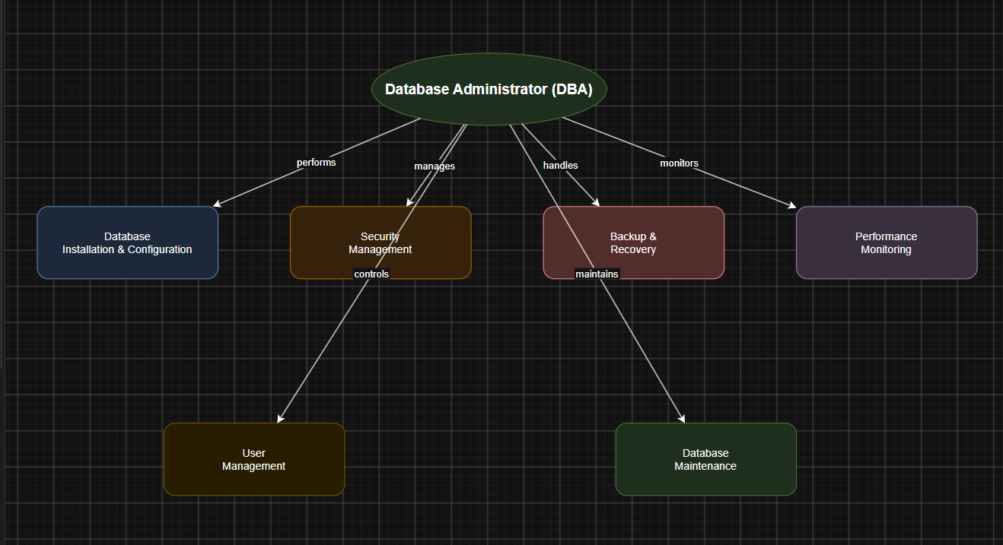

Introduction
A Database Administrator (DBA) is a professional responsible for managing, maintaining, securing, and controlling an organization's databases. The DBA ensures that databases are available, reliable, secure, and perform efficiently. They act as the link between database users, application developers, and the Database Management System (DBMS). A DBA is responsible for protecting data, improving database performance, and ensuring smooth database operations.

Role of a Database Administrator (DBA)
The primary role of a DBA is to manage the entire database system throughout its life cycle. The DBA installs and configures the DBMS, creates databases, controls user access, maintains security, performs backups and recovery, monitors performance, and ensures data integrity. The DBA also works with developers to optimize database applications and supports end users by resolving database-related issues.

Responsibilities of a DBA

1. Database Installation and Configuration
- Installs the Database Management System (DBMS).
- Creates and configures databases.
- Applies software updates and patches.
- Ensures proper database setup.

2. Database Design and Maintenance
- Creates database structures such as tables, indexes, and views.
- Modifies database schemas when required.
- Maintains data consistency and integrity.
- Updates the database according to organizational needs.

3. Security Management
- Creates user accounts and assigns roles.
- Grants and revokes user permissions.
- Protects the database from unauthorized access.
- Implements authentication and encryption techniques.

4. Backup and Recovery
- Performs regular database backups.
- Restores data in case of system failure or data loss.
- Develops disaster recovery plans.
- Ensures business continuity.

5. Performance Monitoring and Tuning
- Monitors database performance.
- Optimizes SQL queries and indexes.
- Removes performance bottlenecks.
- Improves response time and efficiency.

6. Data Integrity and Consistency
- Ensures accurate and consistent data.
- Enforces integrity constraints.
- Prevents duplicate and invalid data.
- Maintains data quality.

7. Storage Management
- Allocates storage space for databases.
- Monitors disk usage.
- Expands storage when required.
- Manages database files efficiently.

8. User Support
- Assists users in accessing the database.
- Resolves database-related issues.
- Provides technical support.
- Trains users on database usage.

9. Database Monitoring
- Continuously monitors database activities.
- Detects errors and failures.
- Generates performance reports.
- Maintains system availability.

10. Documentation
- Maintains database documentation.
- Records backup schedules and recovery procedures.
- Documents database configurations and security policies.
- Keeps maintenance logs for future reference.

Skills Required for a DBA
- Knowledge of DBMS software (Oracle, MySQL, SQL Server, PostgreSQL).
- SQL programming skills.
- Database security knowledge.
- Backup and recovery techniques.
- Performance tuning and optimization.
- Problem-solving and analytical skills.
- Communication and teamwork abilities.

Importance of a DBA
- Ensures data security and privacy.
- Maintains database availability.
- Prevents data loss through backups.
- Improves database performance.
- Supports business operations.
- Protects valuable organizational data.

Conclusion
A Database Administrator (DBA) plays a crucial role in managing and maintaining an organization's databases. The DBA is responsible for database installation, design, security, backup and recovery, performance tuning, storage management, user support, and documentation. By ensuring data integrity, security, and efficient database performance, the DBA helps organizations store, retrieve, and manage data reliably, making them an essential part of any database-driven system.
***

